DATA230 Data Visualization Term Project Report

Shrey Jain  
017450537

**Data Visualization Report**

Overview:

I have created a Tableau Dashboard that provides information about the DRGs in the country of U.S.A. The dataset which we have used for this term project gives us the information about the disease treated in a particular hospital in U.S.A from years 2011-2015. This dataset has key metric information such as Body System Impacted, hospital details, financial figures, and health trends over the year. The aim is to get meaningful information insights through different visualization.

About the DRGs in Health Care Analytics:

Here is why DRG is used in healthcare industry:

1.Reimbursement and Payment Schedule:

Plans are often use DRGs to pay for health care. Hospitals are paid a fixed amount per case under a particular DRG, regardless of actual costs. The program aims to reduce healthcare costs and increase productivity.

2.Population Health Management:

Understanding the frequency of specific DRGs in the community helps address and deliver treatment needs. It can suggest interventions and prevention strategies based on the prevalence or affordability of conditions

3. Research and Policy Development:

DRG data is used by researchers and policymakers in the health care industry to identify patterns, develop guidelines, and make decisions about the best ways to deliver and pay for care.

Overview about the Dataset:

The data which we have used for our term project is publicly available on government data sites.

Data provider: Data.CMS.gov

From here we have collected the data for the years 2011,2012, 2013, 2014, 2015 since we got this data for different years we merged the data in Microsoft Excel and we cleaned our data in the same. The dataset used has more than 900K records to it.

The attributes of my dataset are:

* *Body System Impacted: Clinical system Classification.*
* *County name : Name of the count in which the hospital is located.*
* *DRG with Code: Procedure code classification.*
* *DRG without code : Procedure Classification without code.*
* *Hospital Address: Street Address of the hospital.*
* *Hospital Name: Hospital Name.*
* *Hospital City : City in which a specific hospital is located.*
* *Hospital State: State of hospital.*
* *Hospital Region: region of the hospital.*
* *Hospital Zip Code : Zip code of that hospital.*
* *ID: Identitfier billing for inpatient hospital services.*
* *Medical Department Responsible: Department for specific DRG.*
* *Year: year*
* *Average Covered Charges: A provider’s average fee on services covered by Medicare at. All disposal facilities at the DRG. Because of these differences, each hospital is different hospital cost structures.*
* *Average Medicare Payments: The average Medicare payment for a provider managing a DRG Includes DRG funds, tuition, disproportionate shares, capital and general fees.*
* *Average Total Payments:* *All Medicare payments to the provider for DRG Includes DRG funds, tuition, disproportionate shares, capital and general fees. The words are. Includes coverage and deductibles for which the patient is responsible.*
* *Total Discharges* : *The amount of coverage released by the hospital provider.*

Purpose:

The purpose of this visualization is:

Q1. What are the total discharges by DRG?

Q2. What are the total discharges by each Body System Impacted?

Q3. What is the average cost for a certain disease nationwide?

Q4. What is the average range a patient have to pay if he has a disease?

Q5. Which hospital have provided medical services for a particular DRG & its

          average total payments?

Q6. What are the total discharges by state hospital & time?

Who will use it and what are their goals:

* It is aimed for the users who know about their disease and want more information.
* for the treatment of that particular disease.
* Users who want to see all payments per hospital.
* Users who want to know the total number of discharges for a specific disease in each hospital.
* For users who want to know some basic statistical information about the formulation.
* For drug users who want to know the most common diseases.
* Users who have knowledge of different states of the United States and know the acronyms used.

How did I fulfill the goals?

I used Tableau dashboards and charts to answer the above questions. Also I have used different charts like bar chart, tree map, choropleth map, geo spatial map, boxplot so that the user can look at the display and analyze the information quickly and effectively.

So to answer our 1st question:

Q1. What are the total discharges by DRG?

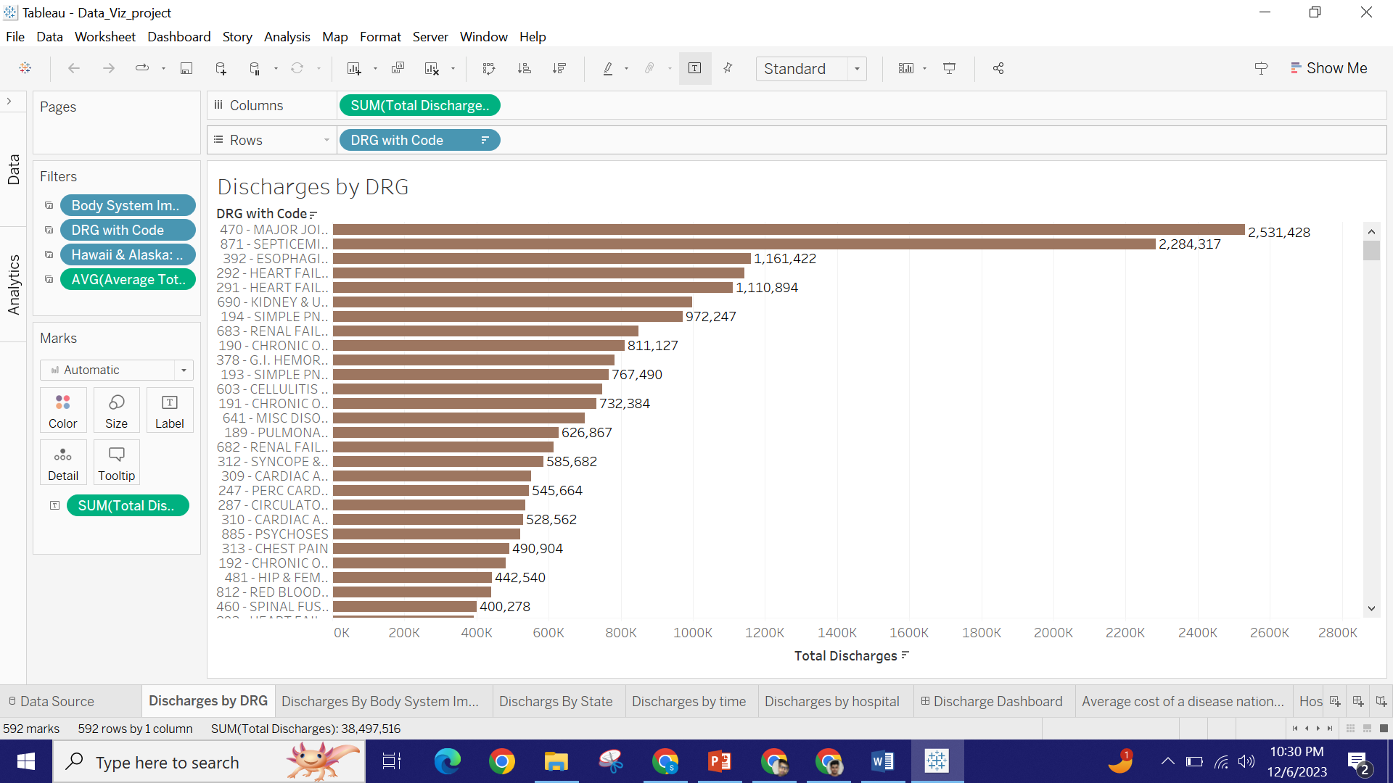

Here we have analyzed the total discharges for each DRG & have created the bar graph in ascending order so we see the DRG with most number of discharges which is Major Joint Replacement and its DRG code of 470. Also there are almost more than 2.5 million discharges across U.S.A.

Q2. What are the total discharges by each Body System Impacted?

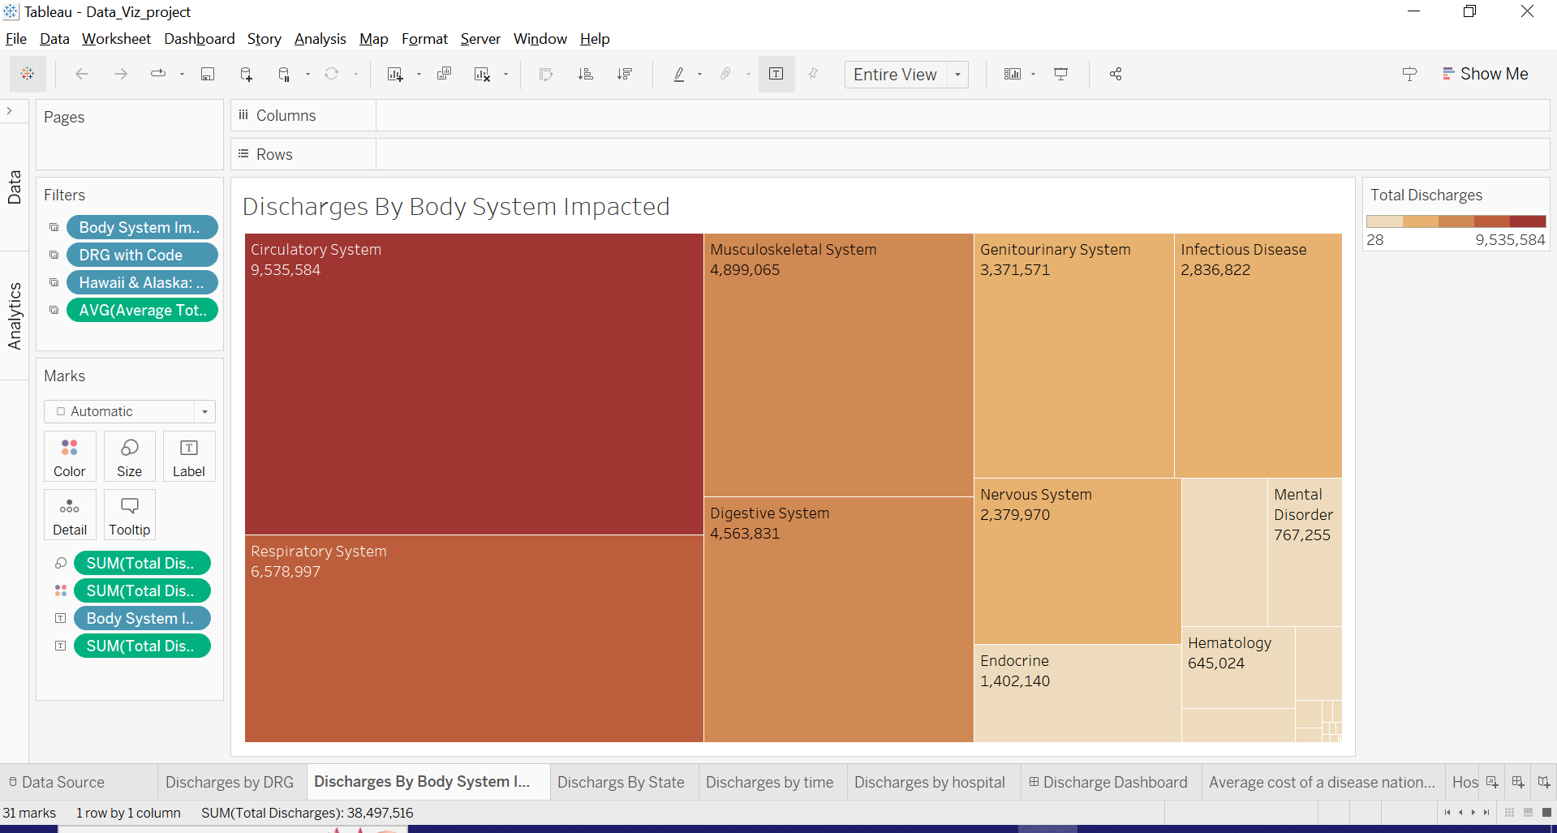

The above tree map shows total discharges across different body system impacted. Each square represents a specific body system & size of square is proportional to the total number of discharges for that system. By looking into it we can say that which body system demands health care services.

Q3. What is the average cost for a certain disease nationwide?

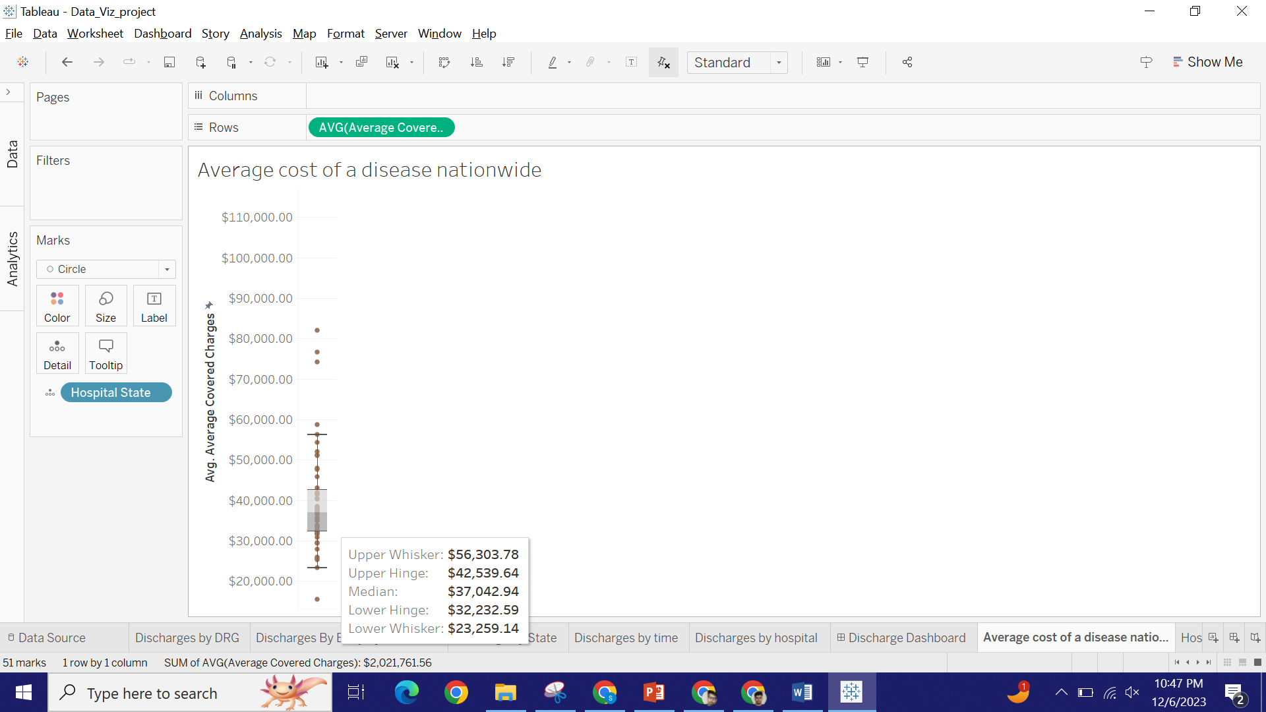

So by looking at our box ploy we can say that for an average cost of a certain disease across the nation would be $37,042. We could also see that there are many outliers it just means that there are hospital who’s average Medicare is much more than other hospital.

Q4. What is the average range a patient has to pay if he has a disease?



So if a person has any of the disease mention in our dataset he /she has to pay anywhere between $23000 to $56000 depending on which state he/she is in.

Q5. Which hospital have provided medical services for a particular DRG & its

average total payments?

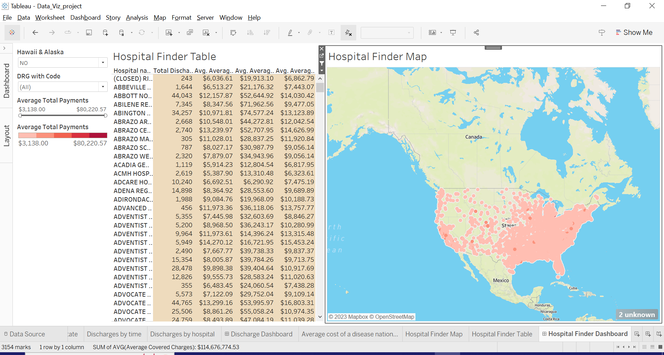

In the above dashboard the user can see the records for each hospitals showing their average Medicare payments, average covered charges, average total payments and they can also compare from different hospital in the same county, also it shows according to the average total payments which hospital provide the specific DRG using the slider feature you can see it. It also shows the address and street view of the hospital.

Q6. What are the total discharges by state, hospital & time?

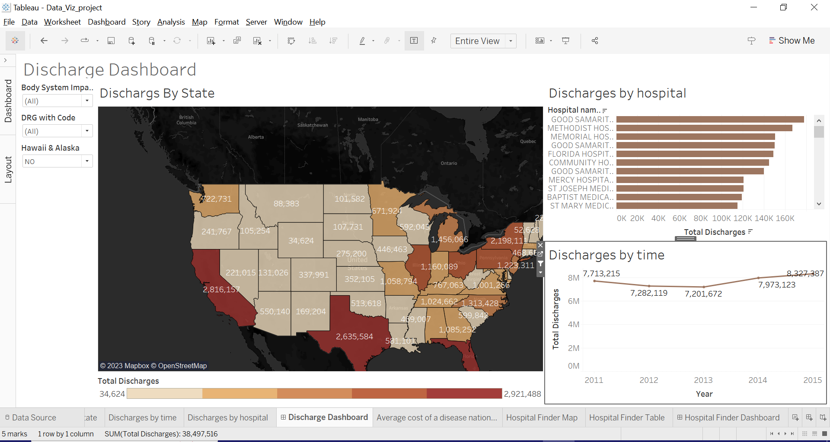

In the above dashboard we can see total discharges by hospital, state, time when we click on the map at any particular state we can see the hospital in that particular state for the specific discharge it also shows the time series analysis of total number of discharges we can select the Body system Impacted and also DRG code and it will show on the map.

Conclusion:

In conclusion, my comprehensive analysis of all discharges across U.S.A, hospitals, and time reveals nuanced understandings of health care dynamics. Combining GEO maps, line charts, and bar graphs, box plot the integrated visualization provides a multidimensional view of the distribution and trends in health care delivery.

Key findings and implications:

Local difference:

We look at differences in health care requirements across U.S.A, emphasizing the importance of sector-specific resource allocation and policy.

Seasonal trends:

Trends in temporal data highlight periods of improvement or decline in health services, facilitating early intervention.

Clinical Administration:

The bar graph sheds light on the performance of individual hospitals, allowing for targeted interventions or support where needed.

Going forward, our insights require targeted actions:

* Explore further in hospitals that exhibit unique patterns.
* Examine the relationship between external factors affecting demand for health care.
* The quality of the product is based on the factors that are required.
* This integrated visualization is not only a descriptive tool but also a strategic guide for health professionals, policymakers, and practitioners, and provides a practical approach to improving resource allocation in and improvement of health services.